**Standard Operating Procedure for Loan Payout**

BAJAJ ALLIANZ LIFE INSURANCE COMPANY

**Function/department - policy servicing**

| VERSION DETAILS | | | |
| --- | --- | --- | --- |
| PROCESS | Policy Servicing - Financial | SUB PROCESS | Loan Payout |
| VERSION NO. | 1.1 | EFFECTIVE DATE | Jun 18, 2025 |
| **AUTHOR** | Prerna Verma/Shadab | **SUBMISSION DATE** | Jun 16, 2025 |
| **REVIEWER** | Sanjeeb Duttagupta | **APPROVAL DATE** | Jun 16, 2025 |
| **FUNCTIONAL HEAD** | Nirmal Paul | **APPROVAL DATE** | Jun 18, 2025 |

**VERSION HISTORY:**

|  |  |  |  |  |
| --- | --- | --- | --- | --- |
| **Date of Release** | **Version No.** | **Approver** | **Remarks** | **Change Process** |
| April 05, 2025 | Version 1.0 | Nirmal Paul | Initial Version | NA |

**Contents:**

VERSION DETAILS 1

SIPOC: 3

REVIEW PROCEDURE: 6

PURPOSE: 6

SCOPE: 6

ROLES AND RESPONSIBILITY: 6

Process METRIC: 9

Process Participants: 9

PROCESS FLOW: 10

PROCEDURE: 11

SCREENSHOTS: 21

USER CHECKLIST: 50

COMMUNICATION: 51

OPUS TO NGIN MIGRATION: 51

SERVICE CONTINUITY: 51

ESCALATION MATRIX: 52

REFERENCES: 52

EXCEPTION PROCESS: 52

KEYWORDS AND ACRONYM: 53

# SIPOC: (Branch Operations)

|  |  |  |  |  |
| --- | --- | --- | --- | --- |
| **Supplier** | **Input(s)** | **Process Overview - Key Steps**   1. Customer branch visit & submits the Loan Request with Mandatory documents ***(Pls refer User check list).*** 2. Br Ops verifies documents (KYC should be self-attested & Form should be duly filled and signed-in by customer & branch seal to be stamped by branch ops). 3. Branch raises SR in CRM and upload the documents, ***(Also performs the penny drop & register DC details).*** 4. SR submitted (Auto GPA Raised) & pushed to Vendor (L1) bucket for processing. 5. Vendor checks all docs & details ***(In case of FR, case flows back to Br ops through CRM status change).*** 6. Post details verification, Partner ID needs to be checked, Basis Penny drop success at branch level, DC should be activated, *(If Penny drop status is failed document will be verified manually and DC will be activated).* 7. If all parameters are within product specification (traditional endowment policies & annuity- saral pension), vendor will execute the payout request in Opus (maker) & SR is auto pushed to HO-PS L3 user bucket. 8. HO-PS L3 user validates 5% cases (irrespective of amount) (HNI - NRI 100% cases) request of the total volume & Re-Verifies the documents, Partner ID and Walk-in Photo with proposal form. 9. Sanction the loan payout through loan batch processing. 10. Policy gets Absolute Assigned to BALIC. 11. GPA gets auto closed & Payout gets released in auto-payout scheduler**. *(In case of CP exception, HO-PS team clears the error & release payout manually through payout team) (If any Tech error, ITHD is raised & IT team resolve the issue for processing)*** 12. Once payout is paid service request will be marked as,” Processed”. | **Output(s)** | **Customer(s)** |
| * Policy holder | Loan Request Form | * Payout processed * SR Closure | * Policy holder |
|  |
|  |
|  |
|  |
|  |
|  |
|  |
|  |
|  |
|  |
|  |
|  |
|  |
|  |

# SIPOC: BITLY (OTC process)

|  |  |  |  |  |
| --- | --- | --- | --- | --- |
| **Supplier** | **Input(s)** | **Process Overview - Key Steps**   1. **OTC Criteria: -** Below 10 L case, Non NRI, with no technical Validation, Penny drop success cases. 2. Customer Branch visit & Submits loan request with documents (Please refer user checklist) 3. Br Ops checks customer’s mobile no. in system & raise SR in CRM and send **Bitly link** to policyholder’s registered mobile number. 4. PH uploads KYC and Bank proof through Bitly link & flows to CRM. 5. Br Ops validates KYC and Bank proof in CRM, (Penny drop status check ***(if Failed, then to proceed via NON OTC process)*** 6. Penny drop Status (if success) OTP is triggered to PH registered mobile number with Loan digital request form & details of Policy number, PH/LA name, Loan Eligible amount, Loan requested amount, Bank account details, etc. 7. If Policyholder is satisfied with all the details customer enters the OTP received on registered mobile number. 8. Br Ops submits SR in CRM, auto GPA is raised & Loan payout request gets generated and auto sanctioned. 9. Policy gets Absolute Assigned to BALIC. 10. GPA gets auto closed & Payout is released in auto-payout scheduler ***(In case of CP exception, HO-PS team clears the error & release payout manually through payout team) (If any Tech error, ITHD is raised & IT team resolve the issue for processing)*** 11. Once payout is paid service request will be marked as,” Processed”. | **Output(s)** | **Customer(s)** |
| * Policy holder | * Loan Request Form. * OTP | * Payout processed * SR Closure | * Policy holder |
|  |
|  |
|  |
|  |
|  |
|  |
|  |
|  |
|  |
|  |
|  |
|  |
|  |
|  |

# SIPOC: BITLY (NON-OTC process)

|  |  |  |  |  |
| --- | --- | --- | --- | --- |
| **Supplier** | **Input(s)** | **Process Overview - Key Steps**   1. **NON-OTC Criteria-** Above 10 Lac case, RI, NRI, Technical validations cases are processed manually through NON-OTC. 2. Br Ops verifies documents (KYC should be self-attested & Form should be duly filled and signed-in by customer & branch seal to be stamped by branch ops). 3. Branch raises SR in CRM and upload the documents, ***(Also performs the penny drop & register DC details).*** 4. SR submitted (Auto GPA Raised) & pushed to Vendor (L1) bucket for processing. 5. Vendor checks all docs & details ***(In case of FR, case flows back to Br ops through CRM status change).*** 6. Post details verification, Partner ID needs to be checked, Basis Penny drop success at branch level, DC should be activated, *(If Penny drop status is failed document will be verified manually and DC will be activated).* 7. If all parameters are within product specification (traditional endowment policies & annuity- saral pension), vendor will execute the payout request in Opus (maker) & SR is auto pushed to HO-PS L3 user bucket. 8. HO-PS L3 user validates 5% cases (irrespective of amount) (HNI - NRI 100% cases) request of the total volume & Re-Verifies the documents, Partner ID and Walk-in Photo with proposal form. 9. Sanction the loan payout through loan batch processing. 10. Policy gets Absolute Assigned to BALIC. 11. GPA gets auto closed & Payout gets released in auto-payout scheduler**. *(In case of CP exception, HO-PS team clears the error & release payout manually through payout team) (If any Tech error, ITHD is raised & IT team resolve the issue for processing)*** 12. Once payout is paid service request will be marked as,” Processed”. | **Output(s)** | **Customer(s)** |
| * Policy holder | * Loan Request Form. * OTP | * Payout processed * SR Closure | * Policy holder |
|  |
|  |
|  |
|  |
|  |
|  |
|  |
|  |
|  |
|  |
|  |
|  |
|  |
|  |

**SIPOC: (Digital Journey Life Assist and Customer Portal- OTC)**

|  |  |  |  |  |
| --- | --- | --- | --- | --- |
| **Supplier** | **Input(s)** | **Process Overview - Key Steps**   1. **Criteria: -** Below 10L case, Non NRI, no technical Validation, Penny drop successful cases are auto processed 2. Customer submits request through life assist / customer portal 3. **If penny drop is successful**: OTP is triggered to PH’s registered mobile number with Loan digital request form with all the details like Policy number, LA/PH Name, Loan Eligible amount, Loan requested amount, Bank account details, ***(Please Refer User checklist for detailed documents required)*** 4. If Policyholder is satisfied with all the details customer will enter the OTP received on registered mobile number. 5. Post SR submission auto GPA is raised & Loan payout request gets generated and auto sanctioned. 6. Policy gets Absolute Assigned to BALIC. GPA gets auto closed. 7. In next payout scheduler payout gets paid in system. 8. CRM SR is auto closed as ‘Processed’ status. 9. Service request gets auto closed in “Processed” status  * ***If the case is not falling under above criteria, then request has to process via NON OTC journey*** | **Output(s)** | **Customer(s)** |
| * Policy holder | * Life assist / customer portal * OTP | * Payout processed * SR Closure | * Policy holder |
|  |
|  |
|  |
|  |
|  |
|  |
|  |
|  |
|  |
|  |
|  |
|  |
|  |
|  |

# SIPOC: (Whats App-OTC)

|  |  |  |  |  |
| --- | --- | --- | --- | --- |
| **Supplier** | **Input(s)** | **Process Overview - Key Steps**   1. **Criteria: -** Below 10L case, Non NRI, no technical Validation, Penny drop successful cases are auto processed. 2. Customer submits request through WhatsApp BOT. ***(Home menu > more services > loan corner > Apply Loan)*** 3. Post policy selection screen will show eligible amount and rate of interest. Customer proceeds if satisfied with all details. 4. 2 options for processing further with the existing account details or new account  * **For existing bank details**, Customer needs to confirm the bank account details, verify it through OTP validation and penny drop. * **For adding new bank account details**, PH needs to fill account number, bank name, IFSC code, Branch name, Account type, Bank city etc, he need to upload bank proof post successful penny drop account will get activated.  1. Post penny drop success; request is verified through OTP & gets submitted. 2. Post SR submission auto GPA is raised & Loan payout request gets generated. 3. Payout gets auto sanctioned in payout scheduler. 4. Policy gets Absolute Assigned to BALIC. GPA gets auto closed. 5. Service request is auto closed in “Processed” status   ***If the case is not falling under above criteria, then request has to process via NON OTC journey*** | **Output(s)** | **Customer(s)** |
| * Policy holder | * Whatsapp BOT Options * OTP | * Payout processed * SR Closure | * Policy holder |
|  |
|  |
|  |
|  |
|  |
|  |
|  |
|  |
|  |
|  |
|  |
|  |
|  |
|  |

**REVIEW PROCEDURE**

|  |
| --- |
| This document needs to review **every Quarter** of the FY, for adding/modifying any addendum or changes levied by the Regulatory Authority or as per the decisions taken by the concerned stakeholders for the governance of the Loan payout process. |

**PURPOSE**

|  |
| --- |
| The said SOP is formed to execute the loan payout request as per product specification (if any) and is always in the same manner in reference to the procedure. |

**SCOPE**

|  |
| --- |
| Scope of the process is limited to the document collection, request registration in CRM Module under respective sub-category. Loan request generation with DC registration, uploading documents, verification of the documents, activation of the bank details against the Policy Number in system, Level 2 approval and CRM SR Closure with processing of pay-out. |

**ROLES AND RESPONSIBILITY**

|  |  |
| --- | --- |
| **ROLE** | **RESPONSIBILITY** |
| Loan request registration | **Branch Operations** |
| Loan Request validation and processing | **Policy Servicing** |
| Corrections required due to any system bug | **Technology** |
| Issue related to any financial accounting error | **Finance** |
| Communication to Policy Holder | **CCM** |

# Process METRIC:

|  |
| --- |
| IRDAI TAT- 7 days  Internal TAT – 2 Days |

# 

# Process Participants:

|  |
| --- |
| Policy Servicing  Branch  Information Technology  Finance  Customer communication |

**Logics**

|  |  |
| --- | --- |
| **3 logics for Loan payout (Broken period, Interest logic, Foreclosed intimation)**     1. Interest computation for broken period.   **No of days in locking period = (Nearest of half yearly Anniversary date or yearly Anniversary date) - loan paid date;**  Interest in locking period is calculated using below formula:  **locking period loan interest = loan amount * loan interest percentage * (no of days from loan paid to locking period)/365;**   * After Locking Period, Simple interest is applicable up to next yearly anniversary (calculation from loan paid date). This is monthly calculation. **Loan Interest= Loan amount * loan interest percentage * (no of days within particular months )/365;** * Thereafter, compound interest will be applied and calculated as below.   **Loan Interest= (Outstanding Principal+ interest till last month) *loan interest percent*(no of days within particular months)/365;**     1. Interest calculation logic for partial / full re-payment of loan.  * For Full re-payment: - Till date interest is getting calculated for repayment. * For Partial re-payment: -Till last month anniversary date interest is getting calculated for repayment.      1. Frequency and details of communications shared with policyholder during loan disbursement / foreclosure etc.  * Intimation letters for foreclose: -  Loan + Interest exceeded surrender value of 95% and 97% | **PS , Technology and Finance** |

**PROCESS FLOW (Branch Operations)**

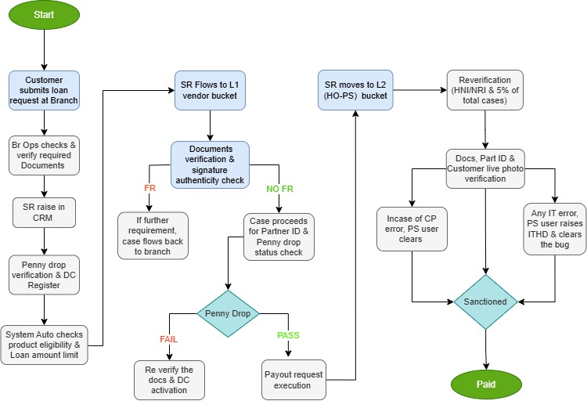

**PROCEDURES (Branch Operations):**

|  |  |  |
| --- | --- | --- |
| **PROCEDURE NAME** | **TASK** | **DEPARTMENT RESPONSIBLE** |
| **Loan request registration (Branch Operations)** | * Customer approaches the BALIC branch and submits the policy servicing request form along with following mandatory documents namely: Loan application form, Assignment form, NEFT proof, KYC. (Pls refer user list section) * Branch Operations collects required documents and scrutinize.   (KYC should be self-attested by customers & branch seal to be stamped by branch ops)   * Branch to raise service request in CRM and upload the documents, Form should be duly filled and signed-in by customer. * **Submit for Processing** – Branch will register the DC after performing Penny Drop * Once service request is submitted an auto-GPA is raised & pushed to Vendor bucket (L1) for processing | **Branch Ops** |
| **Vendor L1(Level-1)** | * The vendor user verifies all the mandatory documents in CRM and ensures that the signature on all the uploaded documents matches with the signature previously present in BALIC records. * If any further requirement is there, vendor marks requirement in CRM module & change SR status to further requirement to branch. * After the document verification is completed, Partner ID needs to be checked, Basis on Penny drop success at branch level, DC should be activated, If Penny drop status is failed document will be verified manually and DC will be activated. * If all parameters are within product specification (traditional endowment policies & annuity- saral pension), vendor user will execute the payout request in Opus (maker) * Service request auto push to HO-PS L3 user bucket | **Vendor** |
| **HO-OPS (Level-2)** | * HO-PS L3 user to validate the 5% (irrespective of amount) (HNI - NRI 100% cases) request of the total volume and sanction the loan payout through loan batch processing. * Cross Verification of the documents, Partner ID and Walk-in Photo with proposal form. * Loan payout request gets generated and auto sanctioned. Policy gets Absolute Assigned to BALIC. * GPA gets auto closed. In next payout scheduler payout gets paid in system. * Payout gets paid in auto-payout scheduler except CP exception cases * **CP exception cases** have to be verified by HO-PS-L3 user and get released manually through payout team. * **CP scenarios**: *EXIT PAYOUT already done for policy no., Bank Reconciliation pending for receipting of policy, missing bank account details, account number mismatch CP account number, sanction amount not match* * Once payout is paid service request will be marked as,” Processed” * **Note:** If penny drop is success at the CRM level then No penny drop should be performed at L3 level | **PS** |
| **Correction through back-end IT system** | If Correction is required in loan accounting due to non-clearance of repayment receipt or loan statement due to any system bug(loan repayment receipt not adjusted, loan accounting not triggered), then ITHD is to be raised for getting such corrections done from backend IT Team with the help of finance | **IT & Finance** |

**PROCESS FLOW (BITLY):**

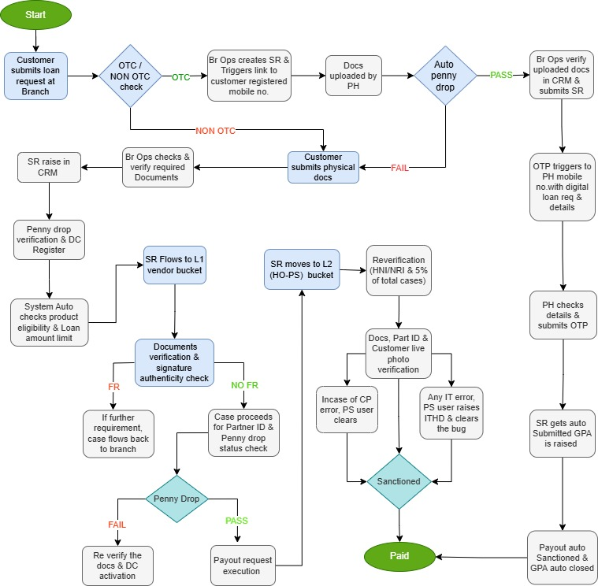

**PROCEDURE (BITLY):**

|  |  |  |
| --- | --- | --- |
| **PROCEDURE NAME** | **TASK** | **DEPARTMENT RESPONSIBLE** |
| **Branch - Loan request generation (OTC)** | * **Below 10 L case:** Non NRI, with no technical Validation, Penny drop success cases are processed and GPA is auto triggered and cases are auto sanctioned and paid through scheduler. * Customer visit branch to submit loan request against his/her policy. * If policyholder mobile number already registered against the policy   Branch Operations raise SR in CRM and send **Bitly link** to policyholder’s  registered mobile number   * Policyholder uploads his/her KYC and Bank proof through Bitly link which gets uploaded with SR in CRM * Branch Operations will validate KYC and Bank proof, if found ok then completes the SR journey * **If Penny Drop is unsuccessful:** Auto penny drop will be triggered but if penny drop is unsuccessful then loan will be processed as per NON OTC journey * **If penny drop is successful**: OTP will be triggered to Policyholder’s registered mobile number along with Loan digital request form with all the details like Policy number, Policyholder/Life Assured name, Loan Eligible amount, Loan requested amount, Bank account details. * If Policyholder is satisfied with all the details customer will enter the OTP received on registered mobile number. * Post SR submission auto GPA is raised & Loan payout request gets generated and auto sanctioned. Policy gets Absolute Assigned to BALIC. GPA gets auto closed. In next payout scheduler payout gets paid in system * CRM SR get auto closed as ‘Processed’ status. | **Branch** |
| **Branch - Loan request generation**  **(Non – OTC)** | * **Above 10Lac case**: RI, NRI, Technical validations cases are processed manually through non-otc. * Branch Operations to collect required documents and Scrutinize for requirements, KYC should be self-attested by customers & branch seal to be stamped by branch ops. * Branch to raise service request in CRM and upload the documents, Form should be duly filled and signed-in by customer. * Submit for Processing – Branch will register the DC after performing Penny Drop * Once service request is submitted will be pushed to Vendor bucket (L1) for processing | **Branch** |
| **Vendor L1**  **(Level-1)** | * Vendor user verifies all the mandatory documents in CRM and ensures that the signature on all the uploaded documents matches with the signature previously present in BALIC records. * After the document verification is completed, Partner ID needs to be checked, Basis on Penny drop success at branch level, DC should be activated, If Penny drop status is failed document will be verified manually and DC will be activated. * If all parameters are within product specs, vendor user will execute the payout request in Opus (maker) * Service request auto push to HO-PS L3 user bucket with status Pending for L3 Approval | **Vendor** |
| **HO-OPS (Level-2)** | * HO-PS L3 user to validate the 5% request (HNI- NRI 100% cases) of the total volume and sanction the loan payout through loan batch processing. * Cross Validates the documents, Partner ID and Walk-in Photo with proposal form (wherever applicable) * Payout gets paid in auto-payout scheduler except CP exception cases, which has to be verified by HO-PS-L3 user and get released manually through payout team * Once payout is paid service request will be marked as, ”Processed” | **PS** |
| **Correction through back-end IT system** | * If any loan SR gets error due to system bug, ITHD is to be raised and resolved through back-end IT * For CP exception errors (PS team clears the same with the help of IT) (Please Refer Branch Walkin Procedure) | **Technology & PS** |
| **CCM** | * Post loan payout, communication shall be auto triggered in CCM to Policy Holder. | **CCM** |

**PROCESS FLOW: (Digital Journey Life Assist and Customer Portal- OTC)**

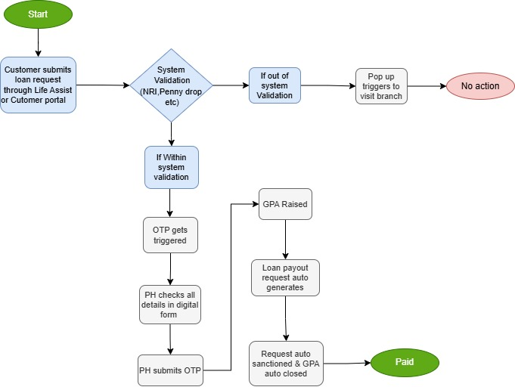

**PROCEDURE: (Digital Journey Life Assist and Customer Portal- OTC)**

|  |  |  |
| --- | --- | --- |
| **PROCEDURE NAME** | **TASK** | **DEPARTMENT RESPONSIBLE** |
| **Loan request** | * Customer places request through life assist / customer portal * **Below 10L case**, Non NRI, no technical Validation, Penny drop successful cases are auto processed * **If penny drop is successful**: OTP will be triggered to Policyholder’s registered mobile number along with Loan digital request form with all the details like Policy number, Policyholder/Life Assured name, Loan Eligible amount, Loan requested amount, Bank account details, (Please Refer User checklist for detailed documents required) * If Policyholder is satisfied with all the details customer will enter the OTP received on registered mobile number. * Post SR submission auto GPA is raised & Loan payout request gets generated and auto sanctioned. * Policy gets Absolute Assigned to BALIC. GPA gets auto closed. In next payout scheduler payout gets paid in system. * CRM SR get auto closed as ‘Processed’ status. * Service request gets auto closed in “Processed” status * **If penny drop is unsuccessful** customer has to visit the Branch to place manual request. (Please refer NON-OTC procedure) * **Above 10L, NRI**, Technical validations (bank recon etc), Further Loan, Exception cases are processed manually ***(Please refer NON-OTC procedure).*** * **Customer gets pop up on screen as unable to process please visit branch.** | **PS** |
| **Correction through back-end IT system** | * If any loan SR gets error due to system bug, ITHD is to be raised and resolved through back-end IT * For CP exception errors (PS team clears the same with the help of IT) (Please Refer Branch Walkin Procedure) | **Technology & PS** |
| **CCM** | * Post loan payout, communication shall be auto triggered in CCM to Policy Holder. | **CCM** |

**PROCESS FLOW (Whats App-OTC):**

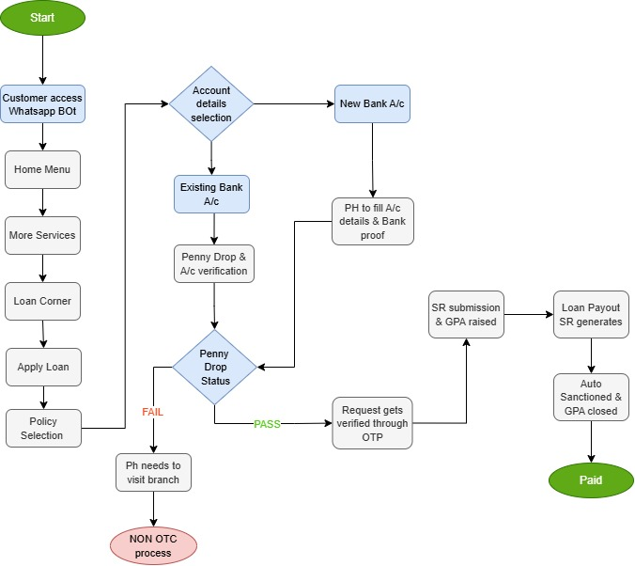

**PROCEDURE (Whats App-OTC):**

|  |  |  |
| --- | --- | --- |
| **PROCEDURE NAME** | **TASK** | **DEPARTMENT RESPONSIBLE** |
| **Loan request** | * Customer places request through WhatsApp BOT. * Home menu>more services>loan corner> Apply Loan * Select policy where you want to apply loan, it will show eligible amount and rate of interest. * It has 2 option for processing further with the existing account details or new account * For existing bank details, Customer needs to confirm the bank account details, verify it through OTP validation and penny drop. * In case of adding new bank account details, need to fill account number, bank name, IFSC code, Branch name, Account type, Bank city etc, he need to upload bank proof post successful penny drop account will get activated. * Below 10 L case, Non NRI, no technical Validation, Penny drop successful cases are auto processed. * When penny drop is successful request will be verified through OTP & gets submitted. * Post SR submission auto GPA is raised & Loan payout request gets generated and Policy gets Absolute Assigned to BALIC. * Payout gets auto sanctioned in payout scheduler & GPA auto closed. * Service request gets auto closed in “Processed” status * **If penny drop is unsuccessful** customer has to visit the Branch to place manual request. * Above 10 L, NRI, Technical validations (bank recon etc), Further Loan, Exception cases are processed manually. * ***Customer gets pop up on screen as unable to process please visit branch***. | **PS** |
| **Correction through back-end IT system** | * If any loan SR gets in exception due to system bug, ITHD is to be raised and resolved through back-end IT | **Technology** |
| **CCM** | * Post loan payout, communication shall be auto triggered in CCM to Policy Holder. | **CCM** |

**LOAN REPAYMENT:**

|  |  |  |
| --- | --- | --- |
| **PROCEDURE NAME** | **TASK** | **DEPARTMENT RESPONSIBLE** |
| **Loan repayment request- Cheque mode** | **Loan repayment through Cheque mode:**   * Policyholder has to visit branch and submit partial or full loan outstanding * Misc. Receipting will be done against Loan repayment through cashier module * The amount will get adjusted post Cheque clearance confirmation in OPUS | **Branch Walking** |
| **Loan repayment- Customer portal (Net banking, Credit card, Debit card, UPI/UPI scan and Pay** | * Login customer portal through his login credential * Go to loan corner and select Repay Loan option * Policyholder can choose one of below online option- Debit Card, Net- Banking, UPI Id, UPI Scan and Pay * Post which amount debited from customer’s account * MISC receipt get generated and gets accounted against the policy * Since this is online receipting, Amount will get adjusted against loan outstanding on real-time basis. | **Customer portal** |

**SCREENSHOTS:**

**BITLY SCREENSHOTS: -**

**Branch user to place SR in CRM Module under Sub category “Policy Loan”.**

**Screen - 1**

**Click on submit tab, SR status will change to ‘NEW’**

**Screen - 2**

**Fill in the required mandatory details & click on send Bitly**

**Screen – 3**

**Upload documents**

**Screen - 4**

**Once document uploads successfully click on save & proceed:**

**Screen - 5**

**Click on Save & Proceed**

**Screen – 6**

**SR status will change to Processed & pay-out will be paid in scheduler**

**Screen - 7**

**CUSTOMER PORTAL:**

**Login to customer portal**

**Screen – 1 Go to Loan corner**

**Screen - 2**

**Select Policy number & confirm mobile number**

**Screen – 3**

**Read & provide agreement for terms and conditions**

**Enter loan amount**

**Screen – 4 Screen - 5**

**Select bank details & click proceed to validate:**

**Screen - 6**

**Agreement to assignment of policy: Review details:**

**Screen - 7**

**Screen – 8**

**Enter OTP which is sent to registered mobile**

**Screen – 9 Loan request will be generated & paid in next payout scheduler:**

**Screen - 10**

**WHATSAPP JOURNEY Screenshot:**

Loan repayment online mode :-

**LOAN PROCESS (OPUS) SCREENSHOTS: -**

Entering loan form:

Enter Policy no. , SR number & click traditional loan case

Check loan amount values as requested and proceed

Questionnaire to validate and save

Finally Validate request and Save

Loan payout batch processing screen:-

CLICK on K2 process:

CLICK on search:

Select all & sanction batch:

# USER CHECKLIST:

|  |
| --- |
| **L1 Vendor, L2 Vendor & HO PS:**   1. Assignment form 2. Loan Application Form 3. Loan quotation (Not mandatory) 4. Receipt of Loan form 5. Walk-in Photo (Offline branch walk-in) 6. Bank Proof 7. Cancelled Cheque Leaf with Pre-Printed Account Holder Name, Bank Account Number, IFSC code with Bank Branch Details. 8. Latest Past six months Bank Statement with Account Holder Name, Bank Account Number, IFSC code with Bank Branch Details. 9. Bank Passbook with Printed Account Holder Name, Bank Account Number, IFSC code with Bank Branch Details. 10. Bank Name Declaration Form for the exceptional cases, where spelling of the name differs slightly or First Name/Middle Name/Surname abbreviation cases. 11. Signature Specimen form in case of signature mismatch.   **For NRI Customers:**   1. Above process remains the same for NRI Customers, additionally they have to provide the following: 2. Only NRO/NRE Bank Accounts are allowed, if customer has provided NRE account then they have to provide Premium Debit proof also. 3. For the exceptional cases, where spelling of the name differs slightly or First Name / Middle Name / Surname abbreviation cases. Name declaration form to be collected signed by policyholder |

# COMMUNICATION:

# 

|  |  |  |  |  |  |  |  |
| --- | --- | --- | --- | --- | --- | --- | --- |
| **Function** | **Process** | **Type of communication** | **Trigger Logic** | **Trigger Description** | **Data Source** | **Communication Mode** | **Content** |
| Policy Servicing | Loan Payout | Regulatory | T+1 | Once the Payout is approved in system | OPUS | SMS &  Email | Service Request (SRN – xxxxx) for Bajaj Allianz Life Policy No. XXXXXXXXXX Processed/Approved |
| Policy Servicing | Loan Payout | Regulatory | T+1 | Once the Payout is processed & loan disbursed in system | OPUS | Service Request (SRN – xxxxx) Loan against for Bajaj Allianz Life Policy No. XXXXXXXXXX Processed & Loan has been disbursed |
| Policy Servicing | Loan Payout | Regulatory | T+1 | At the time of to communicate outstanding loan amount & repay | OPUS | Loan against policy for Bajaj Allianz Life Policy No. XXXXXXXXXX regarding Loan outstanding and repay |
| Policy Servicing | Loan Payout | Regulatory | T+1 | At the time of to communicate when loan amount is increased by 85%, 90% & 95% of surrender value |  | Loan outstanding against your Bajaj Allianz Life Policy No. XXXXXXXXXX is being increasing by (85%, 90% and 95%) of surrender value of your policy. |

# OPUS TO NGIN MIGRATION:

|  |
| --- |
| In process |

# SERVICE CONTINUITY:

|  |
| --- |
| Service continuity as per company |

**ESCALATION MATRIX:**

|  |  |  |  |
| --- | --- | --- | --- |
| **Name** | **Email ID** | **Escalation** | **TAT** |
| Prerna Verma | [Prerna.Verma@bajajallianz.co.in](mailto:Prerna.Verma@bajajallianz.co.in) | Escalation - 1 | T+3 Days |
| Sanjeeb Duttagupta | [Sanjeeb.Duttagupta@bajajallianz.co.in](mailto:Sanjeeb.Duttagupta@bajajallianz.co.in) | Escalation – 2 | T+4 Days |
| Vivek Jha | [Vivek.Jha@bajajallianz.co.in](mailto:Vivek.Jha@bajajallianz.co.in) | Escalation - 3 | T+5 Days |
| Vandana Menon | Vandana.Menon@bajajallianz.co.in | Escalation - 4 | T+6 Days |

# 

# REFERENCES:

|  |
| --- |
| NA |

# EXCEPTION PROCESS:

|  |  |
| --- | --- |
| EKYC/ CKYC should execute at the time of SR registration by branch | Subject to upgrading in CRM |
| System with flag - Cases won't move ahead until all aspects ( Pan Updation, documents, signature etc.) are verified at the branch level | Branch to verify all docs & proceed |

**Exception scenarios:**

|  |  |
| --- | --- |
| **1.Exit Payout** | * HO User to confirm the payout is made for Surrender/ Maturity/Annuity to the customer. * Post verification, Loan will be accepted or rejected |
| **2.Bank Reconciliation pending for Receipting** | * HO user sends **Finance Recon team** for receipt clearance * Post clearance, Payout will be Auto released to the customer by Payout team |
| **3.** **Payout amt >= four times adjusted premium** | * HO user to check whether customer is eligible for loan * Post eligibility, payout will be processed by Payout team |
| **4.** **Account number mismatch CP account no.** | * HO user to check CP details check with TASA and DC screen * Bank account verification done * Post verifying loan payout will be released by Payout team |

**KEYWORDS AND ACRONYM:**

|  |  |  |  |
| --- | --- | --- | --- |
| **KEYWORD** | **ACRONYM** | **KEYWORD** | **ACRONYM** |
| **BALIC** | Bajaj Allianz Life Insurance Company | **CP** | Client Partner |
| **PS** | Policy Servicing | **KYC** | Know Your Customer |
| **PH** | Policy Holder | **CHQ** | Cheque |
| **LA** | Life Assured | **K1** | 1st User (Maker) |
| **KYC** | Know Your Customer | **K2** | 2nd User (Checker) |
| **OPUS** | Open Product Underwriting System | **DOA** | Delegation Of Authority |
| **TAT** | Turn Around Time | **L3** | Level 3 |
| **NEFT** | National Electronic Fund Transfer | **FR** | Further Requirement |
| **NAV** | Net Asset Value | **ULIP** | Unit Linked Insurance Plan |
| **L1** | Level 1 | **IT** | Information Technology |
| **L2** | Level 2 | **T+1** | Today + 1 working day |
| **DC** | Direct Credit | **T+2** | Today + 2 working day |
| **IRDAI** | Insurance Regulatory and Development Authority of India | **T+3** | Today + 3 working day |
| **GRO** | Grievance Redressal officer | **T+4** | Today + 4 working day |
| **T+5** | Today + 5 working day | **HO** | Head Office |
| **FT** | Fund Transfer | **SB** | Survival Benefit |
| **HDFC** | Housing Development Finance Corporation Limited | **WCC** | Written Communication Cell |
| **VP** | Vice president | **SVP** | Senior Vice president |
| **AVP** | Associate Vice president | **FY** | Financial year |
| **DMS** | Document management system | **CRM** | Customer relationship management |
| **SR** | Service Request | **OTC** | Over the Counter |
|  |  |  |  |